**How to configure a web server using XAMPP:**

**Purpose:**

Serves as a local test server for internal use only and good for testing. Also provides backend services without having to install them.

**Scope:**

Applies to system administrators, IT users, or anybody who would like to make a virtual machine.

**Requirements:**

* A computer with at least 32 GB RAM and 32 GB of memory
* A good internet connection

**Process Overview:**

Part 1 – Downloading and Installing the XAMPP service

Part 2 – Opening the console and starting the XAMPP services

Part 3 – Configuring the XAMPP service to use our custom website

**Process Steps:**

**Part 1 - Downloading and Installing the XAMPP service:**

**Step 1:** On a local browser, search up the XAMPP download site:

Click the Apache Friends download site link

**Step 2:** Download the latest version of XAMPP to your local PC:

2.1 - Wait for the download to finish:

2.2 - Once done, click **Open file**

2.3 – You’ll be prompted with a UAC warning, click **Ok:**

**Step 3:** You will be greeted with the Welcome to XAMPP setup page, **click Next:**

**Step 4:** Leave the default services enabled, **click Next:**

**Step 5:** Select the location for the XAMPP install, **click Next:**

**Note:** Folder MUST be empty, otherwise the installer will not move on.

**Step 6:** Choose your preferred language:

**Step 7:** When your ready, **click Next** to begin installation:

**Step 8:** Wait for the installation to complete (will take a bit of time):

**Step 9:** After the installation is done, click the button for *“Do you want to start the Control Panel now?”* and click **Finish:**

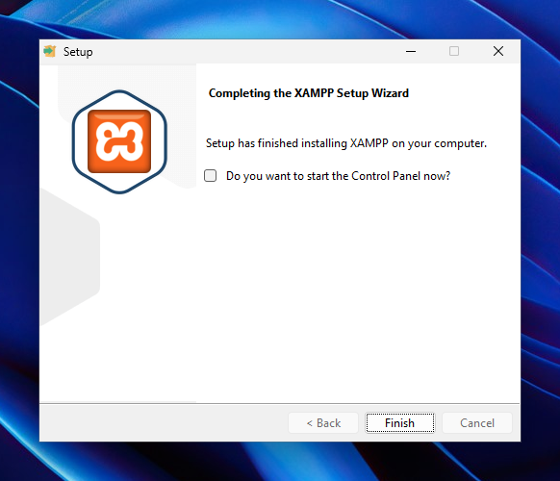

**Part 2 – Opening the console and starting the XAMPP services:**

**Step 1:** On the XAMPP control panel, start the **Apache** and **MySQL** services:

**Step 2:** On the local PC, launch the command prompt. Use the **hostname** command to find the hostname of the local PC:

**Step 3:** Now on the local PC browser, look up the website using the hostname



You will be greeted with the XAMPP default page:

Now we have a working local website!

**Part 3 – Configuring the XAMPP service to use our custom website**

**Step1:** Launch the local PC file explorer:

**Step 2:** Locate where you placed the website earlier:

**Step 3:** In the website folder, locate the **htdocs** folder and click on it:

**Step 4:** In the htdocs folder, locate the **Index.php** file. This is the default file used and is the default webpage. **Rename this file to indexbackup.php** or a different name:

**Now it is named indexbackup.php:**

**Step 5:** Copy this code into a new text file:

<!DOCTYPE html>

<html lang="en">

<head>

<meta charset="UTF-8" />

<meta name="viewport" content="width=device-width, initial-scale=1.0"/>

<title>WCAT - Winnipeg College of Advanced Technology</title>

<style>

body {

margin: 0;

font-family: 'Segoe UI', sans-serif;

background-color: #e6f5e9;

color: #1f3d1f;

}

header {

background-color: #2e7d32;

color: white;

padding: 1rem;

display: flex;

align-items: center;

justify-content: center;

gap: 1rem;

flex-wrap: wrap;

text-align: left;

}

header img {

height: 60px;

}

header .title-group {

max-width: 600px;

}

header h1 {

margin: 0;

font-size: 1.75rem;

}

header p {

margin: 0.25rem 0 0;

font-size: 1rem;

}

nav {

display: flex;

justify-content: center;

background-color: #1b5e20;

}

nav button {

background: none;

border: none;

color: white;

padding: 1rem;

font-size: 1rem;

cursor: pointer;

transition: background-color 0.3s ease;

}

nav button:hover, nav button.active {

background-color: #43a047;

}

section {

display: none;

padding: 2rem;

}

section.active {

display: block;

}

footer {

text-align: center;

padding: 1rem;

background-color: #2e7d32;

color: white;

margin-top: 2rem;

}

table {

width: 100%;

border-collapse: collapse;

margin-top: 1rem;

}

table, th, td {

border: 1px solid #2e7d32;

}

th, td {

padding: 0.75rem;

text-align: left;

}

ul {

list-style-type: square;

padding-left: 1.5rem;

}

</style>

</head>

<body>

<header>

<img src="wcat-logo.png" alt="WCAT Logo" />

<div class="title-group">

<h1>Winnipeg College of Advanced Technology</h1>

<p>Specializing in IT & Computer Science Education</p>

</div>

</header>

<nav>

<button class="tab-button active" onclick="showTab('home', event)">Home</button>

<button class="tab-button" onclick="showTab('courses', event)">Courses</button>

<button class="tab-button" onclick="showTab('schedule', event)">Course Times</button>

<button class="tab-button" onclick="showTab('contact', event)">Contact</button>

</nav>

<main>

<section id="home" class="active">

<h2>Welcome to WCAT</h2>

<p>Your future in technology starts here. Explore cutting-edge IT programs, expert instructors, and real-world learning.</p>

</section>

<section id="courses">

<h2>IT & Computer Science Courses</h2>

<ul>

<li><strong>Intro to Networking</strong> – OSI Model, IP Addressing, Subnetting, Ethernet</li>

<li><strong>CCNA</strong> – Cisco Certified Network Associate, Routing & Switching</li>

<li><strong>Cybersecurity</strong> – Penetration Testing, Risk Analysis, Cryptography</li>

<li><strong>Web Development</strong> – HTML, CSS, JavaScript, Web Security</li>

<li><strong>Cloud Computing Fundamentals</strong> – AWS, Azure, Google Cloud</li>

<li><strong>Server Administration</strong> – Windows Server, Linux, Virtualization</li>

</ul>

</section>

<section id="schedule">

<h2>Course Schedule (Fall 2025)</h2>

<table>

<tr>

<th>Course</th>

<th>Time</th>

<th>Room</th>

</tr>

<tr>

<td>Intro to Networking</td>

<td>8:30 AM – 10:00 AM</td>

<td>Classroom 1, Classroom 2</td>

</tr>

<tr>

<td>CCNA</td>

<td>10:15 AM – 11:45 AM</td>

<td>Classroom 3, Classroom 4</td>

</tr>

<tr>

<td>Web Development</td>

<td>1:00 PM – 2:30 PM</td>

<td>Classroom 5, Classroom 6</td>

</tr>

<tr>

<td>Server Administration</td>

<td>2:45 PM – 4:15 PM</td>

<td>Classroom 7</td>

</tr>

</table>

</section>

<section id="contact">

<h2>Contact Us</h2>

<p><strong>Email:</strong> <a href="mailto:info@wcat.edu">info@wcat.edu</a></p>

<p><strong>Phone:</strong> (204) 555-7890</p>

<p><strong>Address:</strong> 1200 McGillivray Blvd, Winnipeg, MB, R3T 5K4</p>

</section>

</main>

<footer>

&copy; 2025 Winnipeg College of Advanced Technology

</footer>

<script>

function showTab(id, event) {

const tabs = document.querySelectorAll('section');

const buttons = document.querySelectorAll('.tab-button');

tabs.forEach(tab => tab.classList.remove('active'));

buttons.forEach(btn => btn.classList.remove('active'));

document.getElementById(id).classList.add('active');

event.target.classList.add('active');

}

</script>

</body>

</html>

**Step 6:** Now save that file to the htdocs folder:

**Step 7:** Now enter in the **hostname** in another browser. **Only the hostname not** [**http://hostname**](http://hostname)**, this won’t work:**



**Now your greeted with your custom webpage!**

